**ANTI LOCK BRAKING SYSTEM**



Prepared for



The Society of Automotive Engineers

Collegiate Club Number - SAEICCBIS022  
National Institute of Technology Karnataka

Prepared by

Kurma Eshwar Sai Srinivas – 181ME141(Project Mentor)

Patrike Vedika Rajkumar- 191ME256

Diksha Negi-191ME129

April 17, 2021

ABSTRACT

ABS is used in Modern cars to prevent lockup of wheels during braking. It helps to gain control over the steering whenever the wheels get locked. Wheel lock refers to the condition when the wheels stop rotating and the wheels have only translational velocity. In ABS sensors are present near the car wheels which senses if the wheels are rotating or not and

then reduces the brake pressure using modular at times.This provides some intermittent time for rolling and hence gives stability of wheels and steering.

In present work first of all system dynamics equations are explained and a slip ratio is expressed in terms of system dynamic equations are explained and a slip ratio is expressed in terms of system variables namely vehicle linear velocity and angular velocity of the wheel.

By applying a bias braking force system, response is obtained using Simulink models. Using the linear control strategies like P-type, PD-type, PI-type, PID-type the effectiveness of maintaining desired slip ratio is tested.

Table of Contents

SECTION – I INTRODUCTION 2

Timeline 2

Tools and Technologies 2

Brief Introduction 3

Literature Review 3

SECTION – II CONCEPT DEVELOPMENT AND EVALUATION 3

Methodology 3

Results and Discussion 3

Conclusion 3

Future Scope 3

References: 3

# SECTION – I INTRODUCTION

## Timeline

|  |  |  |
| --- | --- | --- |
| Month | Week | Task Accomplished |
| Feb-21 | Two | Completed Theory part and understanding of ABS |
| Mar-21 | Three | Learned Matlab |
| Apr-21 | One | Attended Simulink KEP |
|  |  | Made simulink model of ABS |

## Tools and Technologies

* Matlab & Simulink

## **Brief Introduction**

An antilock system consists of wheel speed sensors, a hydraulic modulator, and

an ECU(electronic control unit). The ABS has a feedback control system that modulates the brake pressure in response to wheel deceleration and wheel angular velocity to prevent the

controlled wheel from locking. The system shuts down when the vehicle speed is below a

pre-set threshold.

What happens when wheels lock?

Front wheels locks :

Loss of steerability due to absence of lateral friction. If the front wheels get locked, the driver loses the steering control. This can be detected more readily by an experienced driver and the driver can regain control by releasing the brakes.

Rear wheels locks:

Rear wheels lockup is more critical as directional stability is lost and there are chances that the car spins out. In this scenario the vehicle over responds to the steering and rear part of the vehicle rotates about its axis if any lateral perturbation is applied to the vehicle.

Force Equations :

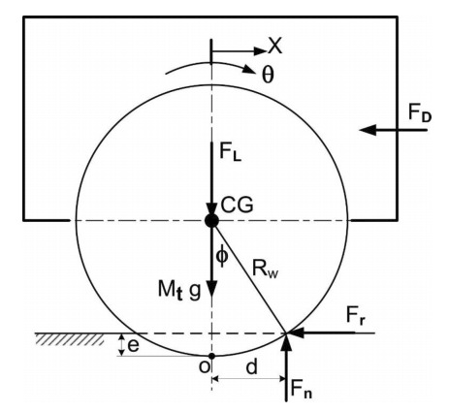

$m a = - μ Fn-Fdrag$

$Fn=Fdown+mg$

$Fdrag=1/2*ρ*Cd*A*{v^{}}^{2}$

$Fdown=1/2*WHFρv^{2}$

$J α = μ R F N - T$

(Wheel slip ratio) λ= (v-ωr)/v

u(λ,v)=[c1(1-e^(-c2λ))-c3λ]e^(-c4v)

c1-> is the maximum value of friction curve;

c2-> the friction curve shapes;

c3-> the friction curve difference between the maximum value and the value at

c4->is the wetness characteristic value. It lies in the range 0.02–0.04s/m.

Where for dry asphalt as the surface condition, above parameters are:

c1 = 1.2801, c2 = 23.99, c3 =0.52, c4 = .03 (assumed)

ρ->air density

W->Wing Span

H->chord of the swing

F->lift coefficient

v-> vehicles longitudinal speed

r-> radius of wheel

ω->angular speed of wheel

a->acceleration

α->angular acceleration of wheel

T-> braking torque

μ->Friction coefficient

r->radius of tire

m->mass of the model

𝜆 = 0 (pure rolling wheel)

𝜆 = 1 (for total skidding)

ABS adjusts the brake pressure so as to get a 20% slip ratio where friction value is max.

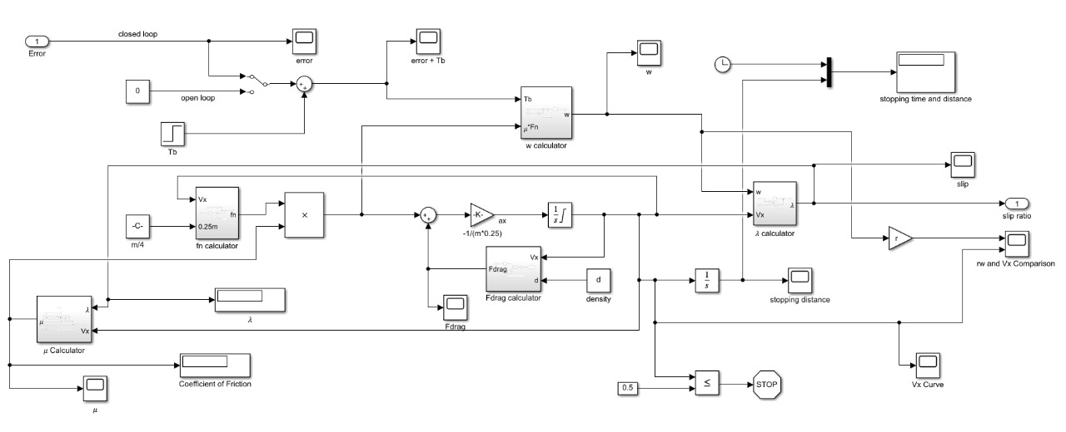

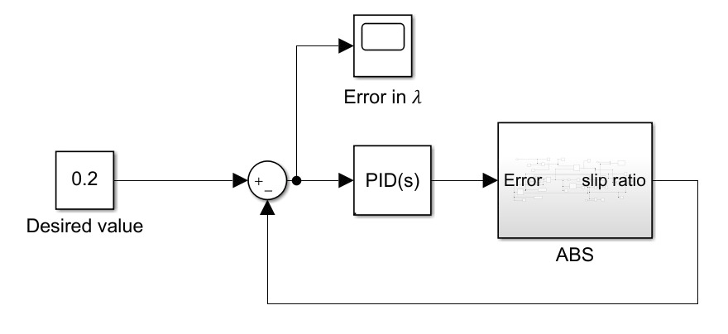

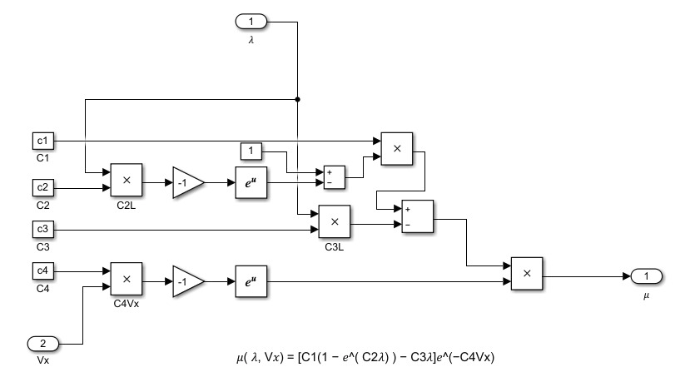

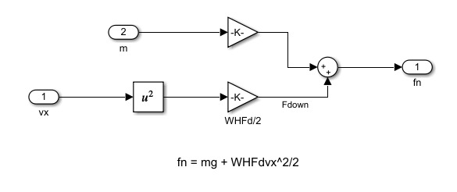

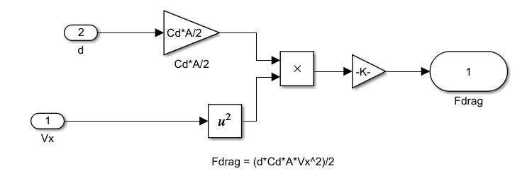

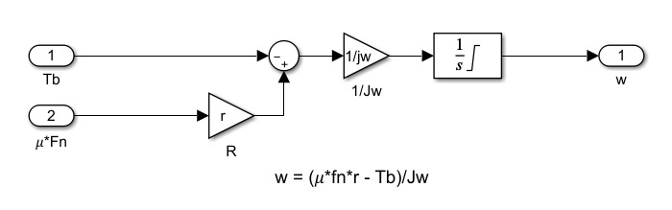

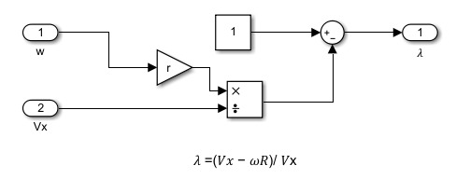

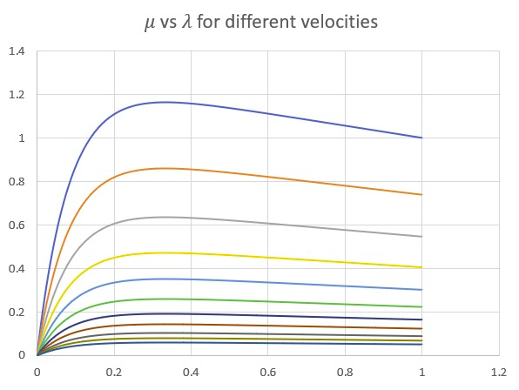

Modulator :

Acts like a hydraulic link between master cylinder and the actuator in the disk brake.

It has three modes:

1. Open mode: Connection remains same
2. Hold mode: closes the connection between MC & WC. WC’s pressure remains constant.
3. Release mode: WC pressure is reduced (by taking fluid back from WC)

Modulator transition between different modes when ECU tells it to.

Balance Bar

The function of a balance bar is to allow the adjustment of brake line pressure distribution between two master cylinders. The torque on one side of the bar must balance the torque on the other side. Balancing bars take the force from one side and give it to the other.

Brake bias/Brake balance

Brake balance, also called brake bias, front to rear, is critical to the stability of a racing car during the braking and during turn-in phase; too much rear brakes will tend to cause the car to spin; too much front and car will not turn in. Brake biasing is only seen in racing cars.

Brake biasing is the condition where we give different brake forces to rear and front wheels. Generally, we give more braking force to the front than to the rear as the centre of gravity tends to move forward when we apply brakes. For the stability of the vehicle both the wheels should skid at the same time. ABS very quickly activates to hold the tyres at (or very close to) maximum braking. Therefore brake bias only matters for the very small amount of time between the brake being applied and ABS being triggered.

As far as the automotive industry is concerned ABS technology is the most recent development in enhancing passenger safety and accident avoidance.

## Literature Review

[Choi](http://acl.kaist.ac.kr/Thesis/2008_CST.pdf) has developed a new continuous wheel slip ABS algorithm. here ABS algorithm,

rule-based control of wheel velocity is reduced to the minimum. Rear wheels cycles

independently through pressure apply, hold, and dump modes, but the cycling is done by

continuous feedback control. While cycling rear wheel speeds, the wheel peak slips that

maximize tire-to-road friction is estimated. From the estimated peak slips, reference

velocities of front wheels are calculated. The front wheels are controlled continuously to

track the reference velocities. By the continuous tracking control of front wheels without

cycling, braking performance is maximized.

[Sharkawy](https://isiarticles.com/bundles/Article/pre/pdf/55641.pdf) studied the performance of ABS with variation of weight, friction coefficient of

road, road inclination etc. A self-tuning PID control scheme to overcome these effects via

fuzzy GA is developed; with a control objective to minimize stopping distance while keeping

slip ratio of the tires within the desired range

# SECTION – II CONCEPT DEVELOPMENT AND EVALUATION

## Methodology

Our main objective of this project is to show how the values of stopping distance and stopping time decreases with the use of ABS, different values of PID tuning were done to achieve 0.2 lambda value and minimize the error. We even added aerodynamic drag and aerodynamic downforce which further decreased both stopping distance and time.

## Results and Discussion

|  |  |  |
| --- | --- | --- |
| Controller | Stopping Time | Stopping Distance |
| Open Loop | 3.527 | 45.73 |
| P Controller | 2.579 | 35.24 |
| PI Controller | 2.578 | 35.22 |
| PD Controller | 2.576 | 35.19 |
| PID Controller | 2.573 | 35.17 |

## 

Open Loop

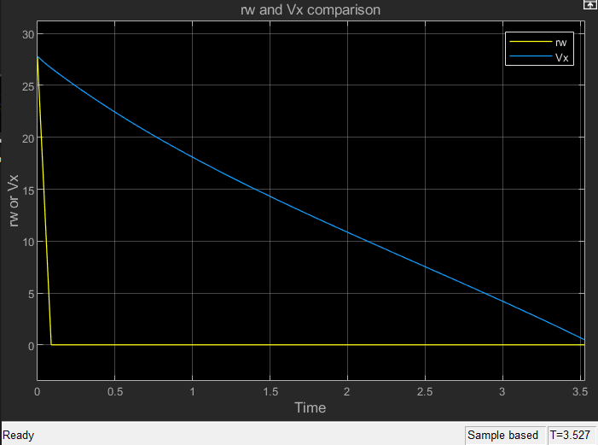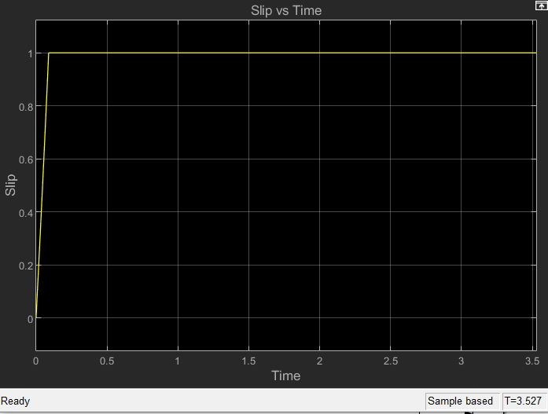

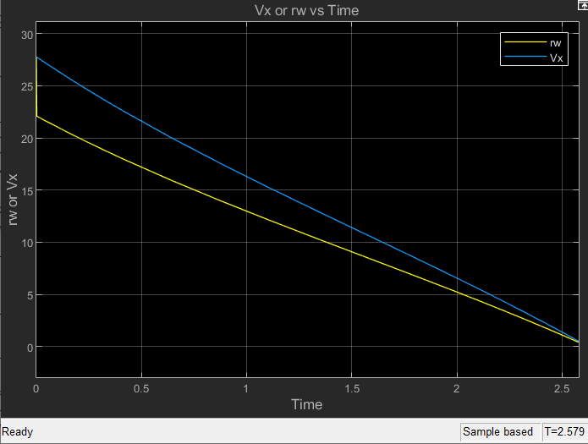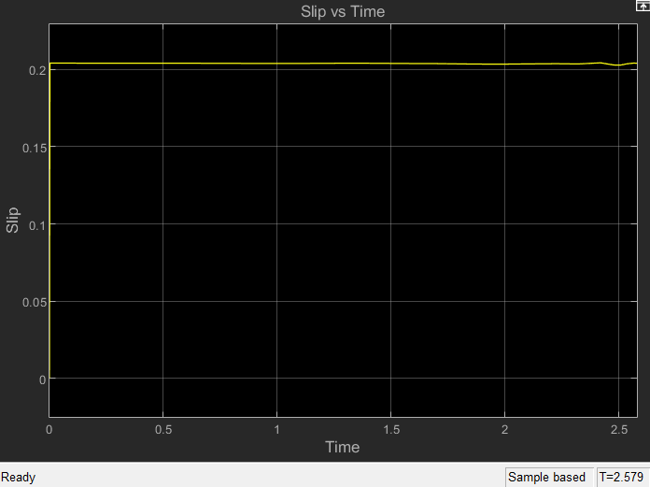

## 

## Future Scope

The current simulations are done for a quarter vehicle model. For future simulations can be done on half vehicle model or even a full vehicle model. Further forces like Roll and Dive forces would be added in a model which consists of more than one wheel. Suspension System can be added to the simulink model and further tuning can be done.

References:

* [NPTEL lectures on ABS](https://nptel.ac.in/courses/107/106/107106088/#)
* [Understanding ABS](https://www.youtube.com/watch?v=98DXe3uKwfc)
* [NPTEL lectures on Vehicle Dynamics](https://www.youtube.com/watch?v=LZ82iANWBL0&list=PLbMVogVj5nJTW50jj9_gvJmdwFWHaqR5J)
* [S. B. Choi, ‘Antilock Brake System with a Continuous Wheel Slip Control to Maximize](http://acl.kaist.ac.kr/Thesis/2008_CST.pdf)

[the Braking Performance and the Ride Quality’, IEEE Transactions on Control Systems Technology, vol. 16, no. 5, September 2008](http://acl.kaist.ac.kr/Thesis/2008_CST.pdf)